

**Attendance Tracking System Requirements**

**────────────────────────────────────**

Members

Alforon, Jhamaica P. Barbarona, Quennie Rose Buhisan, Albert T.

# Project Overview

The Attendance Tracking System is designed to simplify and secure the process of recording student attendance while ensuring data integrity and accessibility. By leveraging cloud-based storage and strong security measures, the system will provide a seamless experience for instructors, students, and administrators.

# System Requirements

## 1. User Management Requirements

**R01.**

The system must allow authorized users to register students and instructors.

## R01.01

Authorized users must be able to upload student ID photos along with personal details (full name, student ID, year level, program, and faculty) during registration. **R01.02**

The system must allow authorized users to remove students or instructors from the system.

## R01.03

Authorized user must have the authority to unregister an instructor’s phone if necessary.

**R01.04**

Only authorized users can access specific features.

**R01.05**

Only authorized users can locate lost registered devices of the instructor.

## 2. Attendance Tracking Requirements

**R02.**

The system must provide attendance tracking functionality for instructors.

## R02.01

Instructors must be able to take attendance using ID Barcode scanning via registered devices (phones or laptops).

## R02.02

Instructors must be able to take attendance using ID Barcode scanning via registered devices (phones or laptops).

## R02.03

The system must allow instructors to drop students who have accumulated three consecutive absences.

**R02.05**

The system must generate attendance reports for authorized users.

**R02.06**

Students must be able to view their attendance records per course.

## 3. Security Requirements

**R03.**

The system must implement strong security measures to protect data integrity. R04.01 Role-Based Access Control (RBAC) must be enforced to restrict access to sensitive data.

**R03.02**

Admin-controlled data encryption must be used to ensure data confidentiality.

**R03.03**

Multi-Factor Authentication (MFA) must be required for instructor logins.

**R03.04**

The system must operate over HTTPS using SSL security protocols.

## 4. Infrastructure & Deployment Requirements

**R04.**

The system must be cloud-based and ensure scalability.

**R04.01**

The system must use MongoDB Atlas or MySQL for cloud-based data storage.

**R04.02**

The system must be accessible and scalable.

**R04.03**

The system must not provide an API for integration with other university systems.

## 5. Deployment Timeline

**R05.**

On May 15, 2025 is the initial checking for the system.

**R06.**

The system must be fully operational and deployed on May 22, 2025.

# Conceptual Model

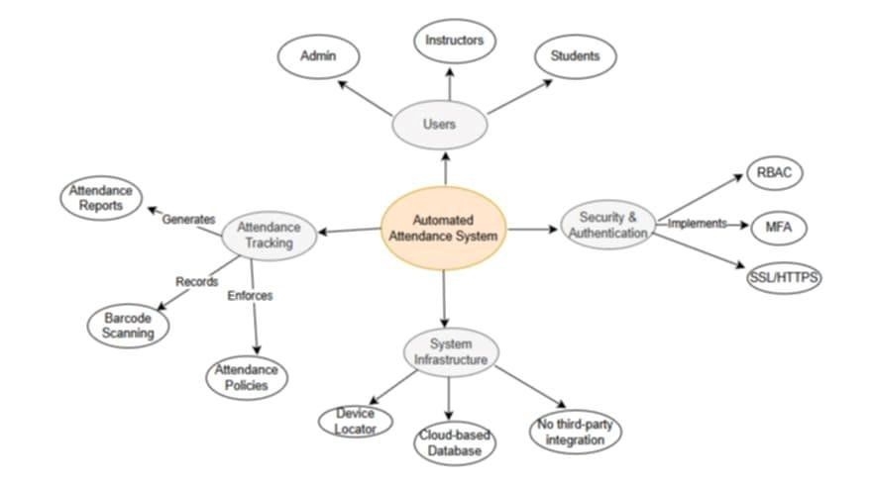

## Overview

The **Automated Attendance System** consists of three primary components:

* **Users**: Admin, Instructors, and Students
* **Attendance Tracking**: Barcode scanning, attendance policies, and attendance reports

### ●Security & Authentication: RBAC, MFA, SSL/HTTPS

●**System Infrastructure**: Cloud-based database, device locator, and no third-party integration

## High-Level Use Case

**Actors and Use Cases:**

* **Admin**: Register/Remove students and instructors, Unregister instructor’s device, Locate lost registered devices.
* **Lecturer**: Take attendance, Drop students, Generate attendance reports, View attendance records.
* **Student**: View attendance records.

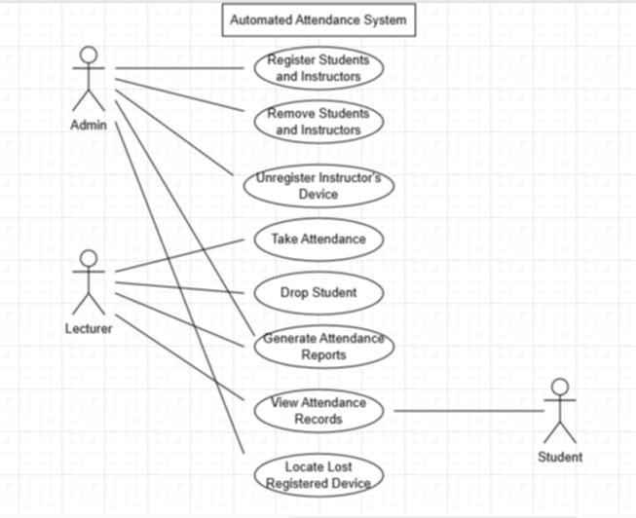

## Traceability Matrix

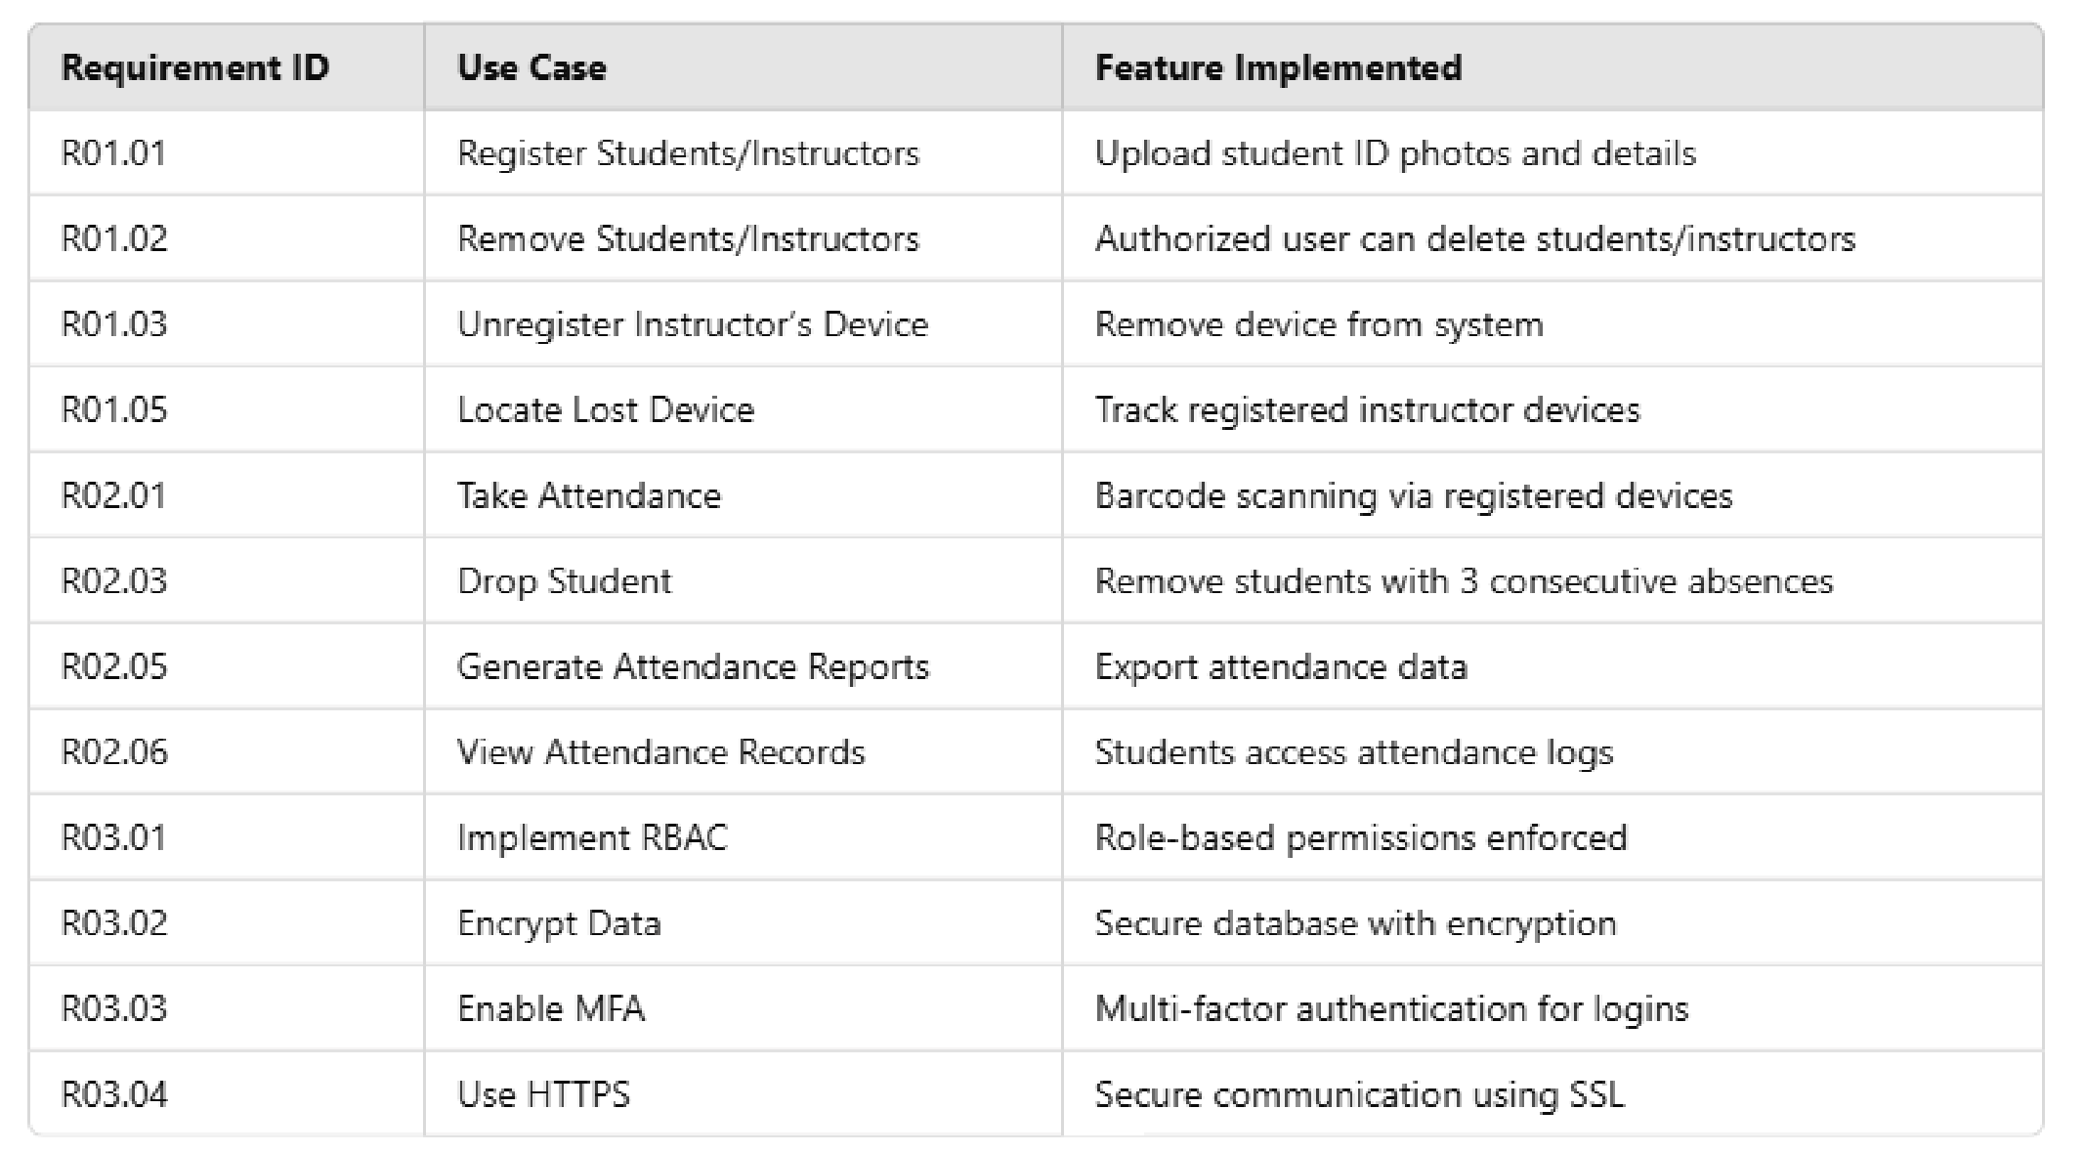

# Project Plan

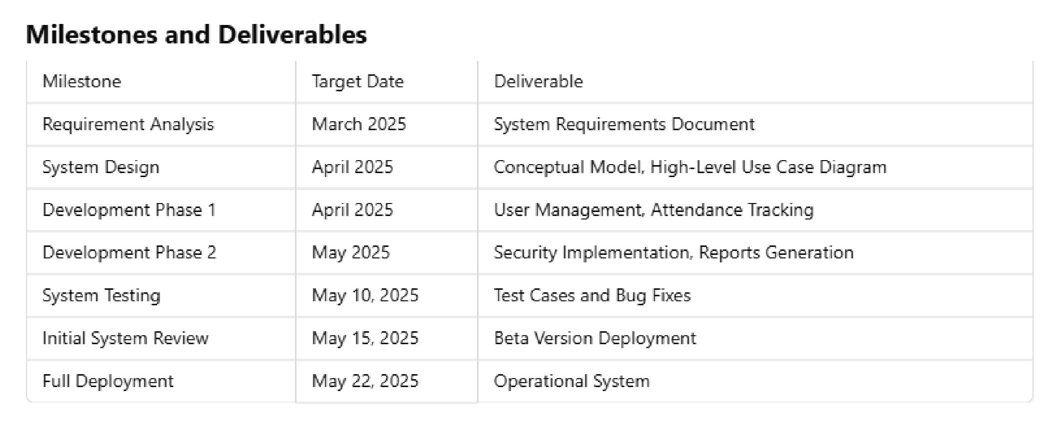

# Git Project Setup

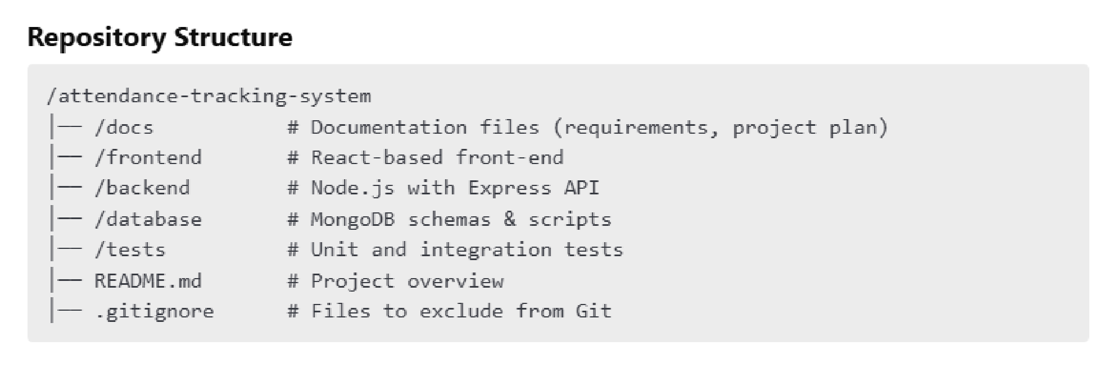

## Git Workflow

### 1. Initialize Repository: git init

1. **Create Main Branch:** git checkout -b main
2. **Feature Branching:**

○git checkout -b feature-user-management

○git checkout -b feature-attendance-tracking

1. **Commit Changes:** git commit -m "Added user registration module"
2. **Push to GitHub:** git push origin feature-user-management 6. **Create Pull Requests (PRs)** for code review before merging.

# Conclusion

This document provides a comprehensive breakdown of the **Attendance Tracking System** covering system requirements, models, use cases, a traceability matrix, project plan, and Git setup. The next steps involve refining the system architecture and starting the initial development phase.